

SPEED TIMING SYSTEM
Announcement August 2014

By Göran Olsson

As the software for Windows and the Timer Box are not ready yet, I have prepared a new Transitrace system for use with old computers with a parallel port and running MS-DOS. People have been waiting long enough, so I hope this will fill the gap.
I bring a few systems to Poland and have them available to those who have ordered and wish to purchase them here.
I have more units which can be shipped shortly.
The Sensor is a completely new design inside, but looks the same. It is completely assembled with battery installed, ready to use. The On/Off switch is removed, and the sensor will turn on automatically when connected to the PC.
The Handle Judge Switch is not delivered in complete state. It is just a microswitch with LED connected to a cable. You have to make a wood grip with trigger yourself.
The present units will be fully useable with the future Windows software and Timer Box.

The system is composed of:
- Sensor Unit
- Sensor to PC Cable, length 7 metres
- Parallel Port Adaptor
- Handle Judge Switch with cable, length 2 metres. (Delivered without grip)
- Extension Cable, length 76 metres, wound on a plastic bobbin (optional, necessary for contest use)
- PC Software Kit, for MS-DOS, downloadable from the Transitrace User web site: http://www.go-cl.se/tt/
- User Manual, also downloadable from the same web site.
You must also provide:
- AN OLD PC Computer, with a parallel port, running MS-DOS alone. A battery operated laptop type is practical for field use. Its screen must be visible in outdoor lighting.
- A sensor Dolly Fender, also serving as rain cover. IMPORTANT!
- Computer Rain Cover and light shield.
- A Grip for the handle switch.

Recommended is also:
- External battery for the PC to allow enough operational time for the planned use.

There is a very important limitation of the present software:
THE TIMING PROGRAM CAN’T BE RUN UNDER WINDOWS.
It needs to be run in MS-DOS only mode!

SENSOR
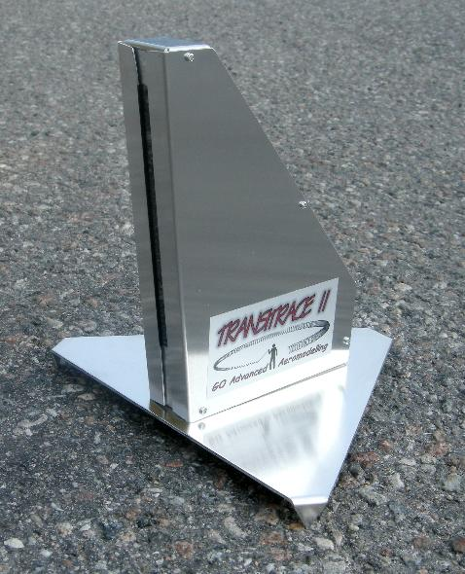

TRANSITRACE PRICES August 2014
Valid in SEK (Swedish Kronor)
EUR and USD according to present exchange rates.
Currency | SEK | EUR | USD
Sensor including 7 meter cable and Handle Switch with cable (without grip) and Adapter Connector for connecting to parallel port on MSDOS PC | 2850 | ~325 | ~435
Extension Cable, 76 meters, to allow sensor position anywhere around the circle  (Necessary for contests) | 800 | ~91 | ~122

E-mail: goran.olsson@ee.kth.se
Telephone: +46-8158320

